The Prehistory of the Cook Valley &

Suggestions for Further Research

Connor Sutton

**Introduction**

The current composition of information regarding the prehistory of the Cook Valley is derived from scattered, disjointed, and altogether unsound sources. This being the case, there are still a series of conclusions we can make about the “Waika”—the term used to denote Native Silurians. This region has been occupied for at least the last 8,500 years, and its inhabitants have undergone a series of transformations in subsistence practices, economy, and settlement patterns throughout this occupation. As we will see, however, it is presently difficult to discuss such changes as we have only a fragmentary understanding of who these Waika are, or if such a general term can be applied to all Native Silurians without combining culturally distinct peoples under one label. Before such topics as the sources of cultural change can be explored, our understanding of those subject to such change must be deepened.

**Background**

One of the earliest dates we can ascribe to Cook Valley occupation is B.P. 8200 ± 150 via radiocarbon dating of charcoal from the Newport Midden, a site which has been poorly and sporadically excavated since the mid-19th century.[1] Our information regarding this site comes from the 1967 excavations by graduate student P. Mott, and since his excavation occurred after many others, it should be noted that the site was probably heavily disturbed prior to his excavation and that the resulting assemblage may be similarly affected.

Mott divided the sequence of layers at the Newport Midden into three distinct periods. Period 1 corresponds to lithic artifacts such as microblades fashioned from blue chert, red chert, and obsidian; projectile points; bones of wild deer and pig; and a barbed bone point. These findings would seem to indicate a mobile hunter-gatherer people. Shell depositions indicate the beginning of Period 2 and a lifestyle more interwoven with marine life. There is a large decrease in the number of identified deer and pig specimens in Period 2, while the number of seal, eel, flounder, cod, and halibut specimens increase dramatically. Wooden longhouses, storage pits, burials, and large quantities of deposited mussels and clams outside the houses imply a sedentary, long-term occupation. Two radiocarbon dates of human bone, 4800 ± 150 and 2720 ± 100 B.P, are supposed to have belong to this period. This leaves at least a 3,000-year gap between confirmable Period 1 and Period 2 occupation. It is thus difficult to say whether Period 2 shows cultural and socioeconomic change in the people of Period 1 or represents a new, culturally distinct people occupying the same space; much can happen in the span of 3,000 years. In the late 1960s, Mott wrote that environmental change may have forced the indigenous populations to adopt new subsistence strategies, and while this may certainly be the case, the available evidence does not rule out the possibility that the people of Period 2 had been using similar subsistence practices since the time of Period 1, and it was only later that their settlements expanded to include the land once inhabited by the hunter-gatherers—a number of similar hypotheses that do not rely on environmental change to influence subsistence could be made. This emphasizes the point that future studies regarding New Silurian prehistory should be more focused on building a sturdier, more cohesive picture of the cultures which inhabited the area before exploring factors that may have led to changes in these cultures.

Period 3 at the Newport Midden shows another socioeconomic shift—longhouses are replaced by small, circular huts; the frequency of freshwater eel declines while deep sea fish become more common; and side-notched projectile points are completely replaced by corner-notched points. Since Mott did not report any findings of burials or storage pits in this period, it seems more likely that the inhabits of this period followed a pattern of seasonal occupation of various sites. This could also explain the replacement of longhouses by small huts. In fact, in James Cook’s brief account of his visit to New Siluria—our first source of information regarding the area or its people—he describes witnessing “a cluster of crude shelters…deserted, with weeds growing over the cold fireplaces.” Cook notes that it seemed the desertion of the village could not have been for many months before his winter arrival. These people, like those occupying Period 3 of the Newport Midden, may have only occupied such areas during specific seasons. This idea is further evidenced by the account of Dutch explorer van Huygen; arriving 13 years after Cook, he barters with the inhabitants of what may have been the very same settlement Cook came across, obviously occupied this time. Radiocarbon dating of charcoal gives our only confirmable date of Period 3 occupation to be 1200 ± 110 years B.P., which leaves a potential gap of ~1,500 years between Periods 2 and 3. Again, it is difficult to say whether such cultural discrepancies are due to environmental change forcing populations to change their lifestyles, culturally distinct peoples immigrating to this area, or some combination of these and other factors.

A variety of other sites have been excavated, although few have thorough documentation, and there have been no systematic surveys of the region. A more cohesive understanding of the people who lived here is required before discussions about the causes of cultural, social, economic, or technological change can begin. Who are the Waika? The origin of this term is not given—likely it is the name given by the people who interacted with first European missionaries in the area to themselves, but even if this is the case, it is not clear how specific the label was meant to be. How many distinct populations occupied the Cook Valley before European colonization? How many communities were quietly extinguished by disease, as occurred so many times in post-Columbian America? The variety of environments in the Cook Valley—mountain ranges; river valleys; dry, interior plains and wet, coastal plains—necessitates a corresponding variety in subsistence strategies, and it is possible that there existed a diversity of societies in New Siluria prior to European immigration. The purpose of future studies in New Silurian prehistory should be to investigate the degree of cultural variation that may have existed between populations. In the next section, I will attempt to statistically identify distinct cultural patterns based on similarities between the archaeological assemblages found at each site.

**Statistical Exploration**

The Coast Range and Central Range mountains flank the Cook Marsh and effectively separate the Cook Valley into four geological quadrants. Obsidian can be found in northwest section, which contains part of the Central Range as well as the dormant volcano Mt. Crater. The northeastern section is home to several red chert outcroppings along. In the southwest is a slate deposit along the Coast Range mountains, and in the southeast are blue chert outcroppings. These geological features play a significant role in the archaeological assemblages of the Cook Valley, and analyzing the quantities of lithics corresponding to each material can inform us about movement, trade, and technology in New Silurian populations. Figures 1 & 2 show percentages by site and layer of flaked lithic raw material, first ordered by position in the east-west axis (Fig. 1) and then by position in the north-south axis (Fig. 2) in order to investigate geographical patterns in lithic assemblages.

Figure 1. A series of charts indicating the proportions of material found at each site, ordered from the most-east to the most-west (left to right, top to bottom).

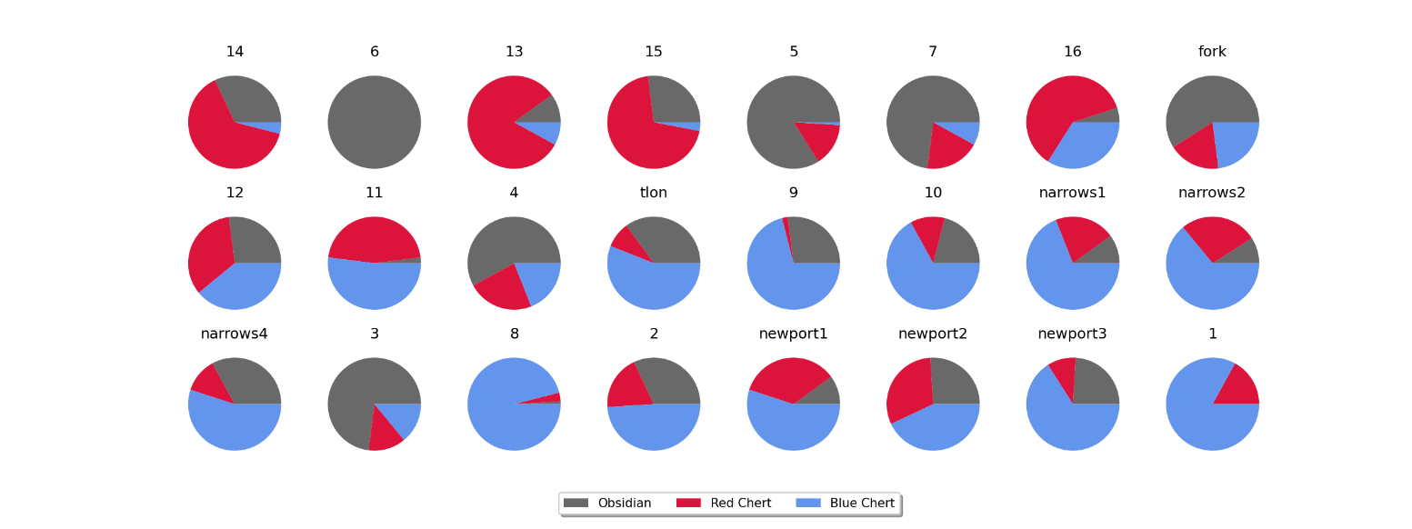

Figure 2. A series of charts indicating the proportions of material found at each site, ordered from the most-north to the most-south (left to right, top to bottom).

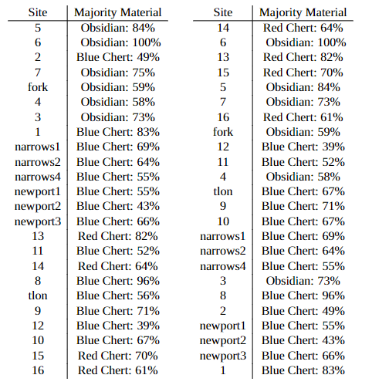Figure 1 shows a predominance of obsidian in the easternmost sites with a shift towards blue chert—and occasionally red chert—as one moves to the west. Figure 2 shows a mix of obsidian and red chert majorities in the northernmost sites with increasing amounts of blue chert as one moves south. This pattern is exactly what we might expect based on the locations of the source materials.[2]

Table 1. Left: sites organized from easternmost (top) to westernmost (bottom) indicating majority material.

*Right: sites organized from northernmost (top) to southernmost (bottom) indicating majority material.*

While geographic position is strong indicator of the raw lithic assemblage of a site, a majority of sites show some combination of all three materials, even when it may be near 100 km away from the source, indicating that trade or communication networks connected distant populations. It should be noted that most of these sites are undated, and it cannot be said yet which sites are contemporaneous with one another. Two of the sites, however—the Newport Midden and the Narrows Site—contained several levels, making analysis of the local trends over time possible.

At the Narrows Site, periods 1 and 2 show near identical lithic distributions. When taken in conjunction with their similar artifact assemblages (see Fig. 3), the evidence indicates technological and economic consistency across this period. These layers date to 8760 ± 220 and 7100 ± 130 B.P., respectively. Period 1 at the Newport Middens is chronologically situated in between these two periods and is characterized by a similar lithic distribution with a slight yet expected bias towards red chert as it is situated further to the south. Each of these three periods corresponds to seasonal occupation by hunter-gatherers. No other dates given by radiocarbon appear within 2,000 years of these three periods (this number can be extended to 5,500 if other periods of the Newport Midden are excluded), which 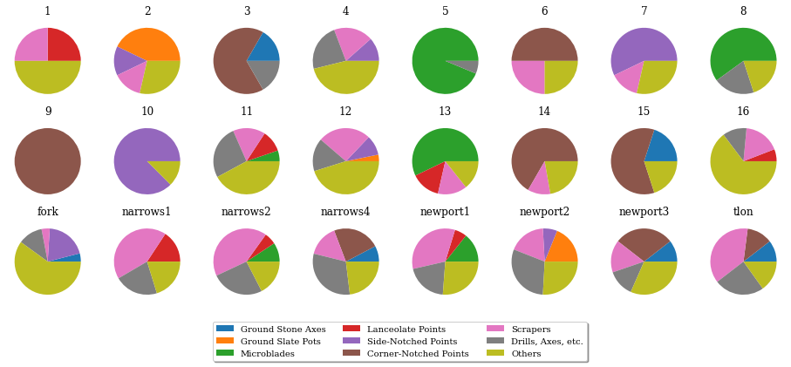complicates further comparison on the basis of chronology.

Figure 3. A series of charts indicating the normalized proportions of artifact types found at each site.

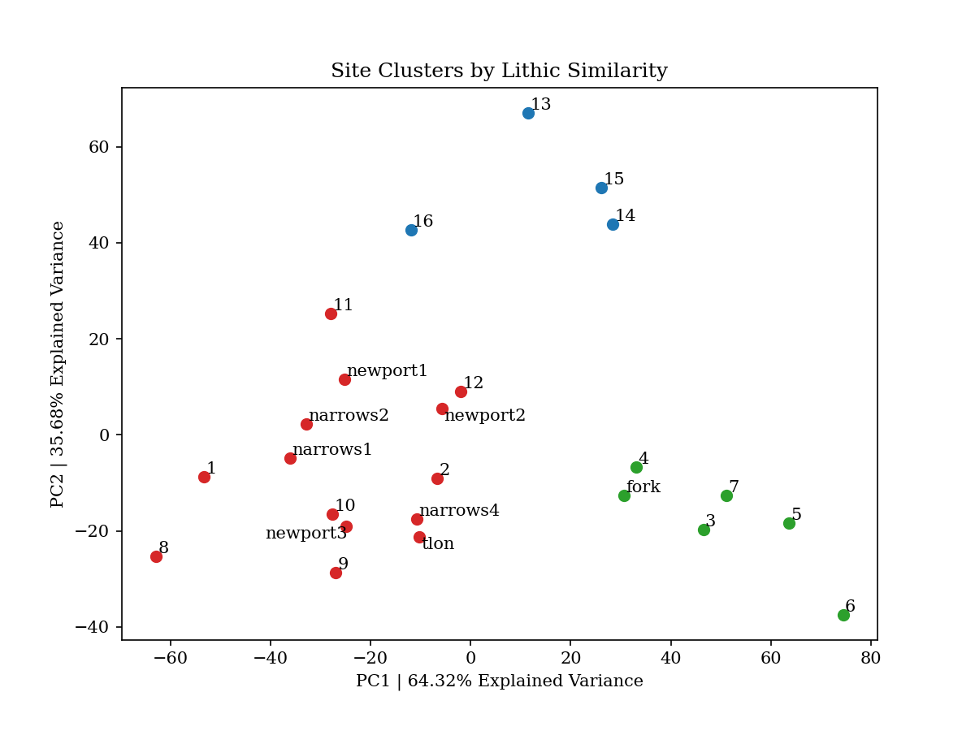Another measure that was taken to attempt to group sites together based on assemblage similarities was to employ *k*-means clustering on both artifact and lithic data. By applying clustering and using Principal component analysis (PCA) to reduce dimensionality from three (obsidian, red chert, and blue chert proportions) to two (PC1 and PC2), we can examine the similarity of site assemblages represented spatially and separate sites into distinct groups.

Figure 4. Graph illustrating the lithic similarities across each site. The color of the point represents its classification. The elbow method was applied to find the optimal k = 3.

Figure 5. Graph illustrating clusters by artifact similarity. Again, the elbow method was applied to find the optimal k = 3.

Figure 5 shows Periods 1 and 2 of the Narrows Site and Period 1 of the Newport Midden to belong to the same cluster, along with a series of other sites. Period 3 of the Newport Midden and Period 4 of the Narrows Site, which are roughly contemporaneous (1200 ± 110 and 1020 ± 120 B.P., respectively), are shown by PCA to be highly similar. These sites are separated by the earlier periods at the same locations by ~7,000 years, yet they appear closer—and, in the case of Narrows, Period 4, placed in the same classification—to these earlier periods than geographically distant sites like “5” and “9”. This exemplifies the possibility that cultural, socioeconomic, or technological differences may vary more with geographical distance than temporal distance amongst the populations of the Cook Valley, but without more information—such as approximate dates for sites “5” and “9”—this remains unclear. Maximal alignment of the classifications created by lithic and artifact similarity yields a 58.3% overlap[3], meaning that lithic assemblage is a weak-to-moderate indicator of artifact types and vice versa.

These results do not provide satisfying cultural categories that cleanly sort out New Silurian populations, but they do hint at the potential complexity underlying Cook Valley population dynamics and demonstrate the need for more robust, cohesive data.

**Suggestions for Further Research**

As has been argued above, a stronger foundational body of knowledge regarding the indigenous populations of the Cook Valley must be built before other questions can be explored. Current information is derived from scattered sources and poorly-documented excavations, and there are significant lacunae that need to be addressed. For example, the origin and meaning of the term ‘Waika’ has not been documented, and there exist no modern ethnographic studies of the Waika people despite the persistence of Waika people in New Siluria and the revival of interest in Waika cultural heritage. The most sensible first step in constructing a reliable body of knowledge is to conduct an ethnolinguistic study of contemporary Waika people to mine as much information as is possible about their culture, language, and history. Who are the Waika? What exactly does this term imply? Are there other names for New Silurian indigenous populations? How long have the Waika lived here? What can be said about their traditional or cosmological belief systems? These are just a few questions that could potentially be answered through ethnography, and their answers would provide researchers would a much stronger frame of reference for interpreting archaeological data.

Additionally, systematic surveying of the Cook Valley region can solidify the flimsy basis that currently exists. For example, the locations of houses such as those found at the Tlon site are hinted at by raised, flat-topped mounds, and patterns of low ridges associated with garden or field boundaries appear in aerial photographs. Aerial photography could thus be used to discover the locations of villages and agricultural fields across the whole of the Cook Valley. In locations characterized by dense forests such as the southern slopes of the Coast Mountains and the coastal plain, LiDAR could be used to penetrate the forest cover and obtain the necessary data. Geographic patterns in detected archaeological features may be explored, providing more information regarding cultural variability based on environmental and geographic factors. Upon the acquirement of cohesive data from surveying, a selection of sites could be chosen for further exploration and potentially excavation based on their expected ability to answer prominent research questions.

Synthesizing information from ethnolinguistic studies of contemporary Waika culture with complete, systematic surveying of the Cook Valley will provide the solid foundation that must necessarily preempt deeper research questions and the design of weightier operations such as further excavations in the Cook Valley. Without such prior knowledge, questions regarding factors of change—e.g., the environmental pressures suggested by Mott—will be operating on incorrect, incomplete, or unsubstantiated assumptions. It is, of course, extremely likely hat environmental pressures forced cultural, technological, political, and economic adaptations in New Silurian populations, but without stronger ideas about the identities of these peoples or the degree of variation in their lifestyles, such discussions will lack the substance and efficiency

1. The earliest date comes from P. Mott’s excavations at the Narrows site where radiocarbon dating of charcoal shows the earliest date to be 8760 ± 220 B.P.
2. Sites “2” and “3” are noticeable outliers on the east—west axis and north-south axis, respectively. These sites appear in the southwest quadrant of the Cook Valley, closest to the slate deposit. Their status as outliers is thus likely due to slate’s lack of representation in these distributions and these sites’ distance from all other material sources.
3. In the case that no correlation existed, we would expect a 33.3% overlap.